MARCO CAPPELLI

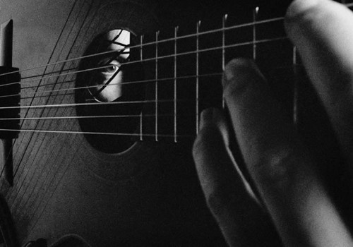
photo by: Danilo Scarpati

Born in Naples - Italy, MARCO CAPPELLI studied classical guitar at the Conservatorio di S. Cecilia in Rome. Supported by a scholarship provided by the Italian Government, he studied with Oscar Ghiglia at the Musik Akademie der Stadt in BASEL - Switzerland, concluding his Konzert-Diplom with a recital featuring a remarkable performance of Le Marteau Sans Maître by Pierre Boulez and Sonata op. 47 by Alberto Ginastera.
He has lead since the middle 90ies an extraordinary artistic path, becoming familiar with rigorous written music as well with free improvisation languages: nowadays Marco Cappelli works as contemporary music interpreter, as side musician for other artists’ projects, as well as composer and band leader and with his original music.
The diversity of Marco’s performances is due to a fascinating array of collaborations: Anthony Coleman, Michel Godard, Butch Morris, Franco Piersanti, Jim Pugliese, Enrico Rava, Marc Ribot, Adam Rudolph, Elliott Sharp, Giovanni Sollima, Markus Stockhausen, Cristina Zavalloni, Raiz... and many more.
He has toured intensively in South Korea, Japan, China, USA, Canada and Europe, being regularly guest - both as a soloist or in ensemble settings - in major classical and contemporary music series (Teatro Massimo in Palermo, Associazione Scarlatti in Napoli, Ravenna Festival, Festival Traiettorie in Parma, Ente Teatro Lirico in Cagliari, Guggenheim Museum in New York, Italian Academy at Columbia University in New York, BAM Fisher Theater in Brooklyn, Salzburg Festival in Austria, Ruhr Triennale and Ludwigsburg Schlossfestspiele in Germany…) as well in jazz and avant-garde music festivals (Saalfelden Jazz Festival in Austria, Pomigliano Jazz Festival in Italy, Barnsdall Theatre e Watts Tower Jazz Festival in Los Angeles , Moma in New York, OutPut Festival in Amsterdam, Montreal Jazz Festival in Canada, Cité de la Musique in Paris, Belgrade Jazz Festival, Cerkno Jazz Festival in Slovenia…).
Very active as soloist, Marco co-founded the acclaimed Italian contemporary music groups ENSEMBLE DISSONANZEN, and leads three band projects: MARCO CAPPELLI ACOUSTIC TRIO, ITALIAN SURF ACADEMY and IDR- ITALIAN DOC REMIX.As side musician, he is member of MARC RIBOT CAGED FUNK, ADAM RUDOLPH'S GO: ORGANIC ORCHESTRA and LCP ENSEMBLE.
Marco has developed a large discography, among which we remember two solo guitar cds : Yun Mu, for the for the Italian label TDS, and EGP-Extreme Guitar Project: Music from Downtown New York for the prestigious American label Mode Records. Mode Records also published two cds by Ensemble Dissonanzen, where Marco is involved in G. Petrassi’s and H.W. Henze’s chamber Music. In 2008 the Italian jazz label Itinera released the first cd of Marco’s band IDR – Italian Doc Remix. In 2011, as memorial for the Twin Towers' attack, Mode Records released In The Shadow of No Towers: a dvd that Marco realized with his band Syntax Error in collaboration with comic artist Art Spiegelman and actor John Turturro, which has been presented in film festival such as Toronto Jewish Film Festival and UK Jewish Film Festival in London). More recently the same label released Les Nuages en France and The American Dream debut albums by, respectively, MARCO CAPPELLI ACOUSTIC TRIO and ITALIAN SURF ACADEMY. In 2013 the second Acoustic Trio cd, due to Marco's collaboration with writer Maurizio De Giovanni and titled Le Stagioni del Commissario Ricciardi , has been released by Tzadik, the prestigious John Zorn's label.
In 2012 Marco scored the film Intervallo by Leonardo Di Costanzo, which has been premiered at 69th Venice International Film Festival and has gained the prestigious price David di Donatello. He composes and plays live music for the New York based Young Soon Kim Dance Company, which after its successful South Korea tour (2012) performed at BAM Fisher Theater in Brooklyn (June 2014). In the Fall 2014, together with actor Andrea Renzi, he premiered the theater play Sonata per il Commissario Ricciardi, produced by Teatro Garibaldi in Palermo and presented at the prestigious Napoli Teatro Festival 2015, with live music by MARCO CAPPELLI ACOUSTIC TRIO. Later in 2015, Marco has been artist in residence at The Stone, the prestigious experimental and avant-garde New York venue directed by John Zorn.
Since 2004 Marco Cappelli made his home in Brooklyn, NY. At the side of his concert activity, Marco Cappelli teaches intensively: he is guitar professor at Conservatorio "Vincenzo Bellini" in Palermo and Associate Professor at Columbia University Music Performance Program in New York. He has taught as assistant with Mrs. Sharon Isbin at Aspen Summer School, and has been "guest professor" at Julliard School, Mannes College and New York University in New York, at Cal Poly University in Los Angeles, at Guadalajara University and at Ecole Sainte Trinité in Haiti.

